Peyton’s Blackbird Story
During lockdown I have been studying a nest I found in my garden when my mum was cutting down trees to put up our trampoline. There was 5 bluey green eggs in the nest so I took a picture and looked up what kind of birds they would hatch into. They were blackbird eggs 

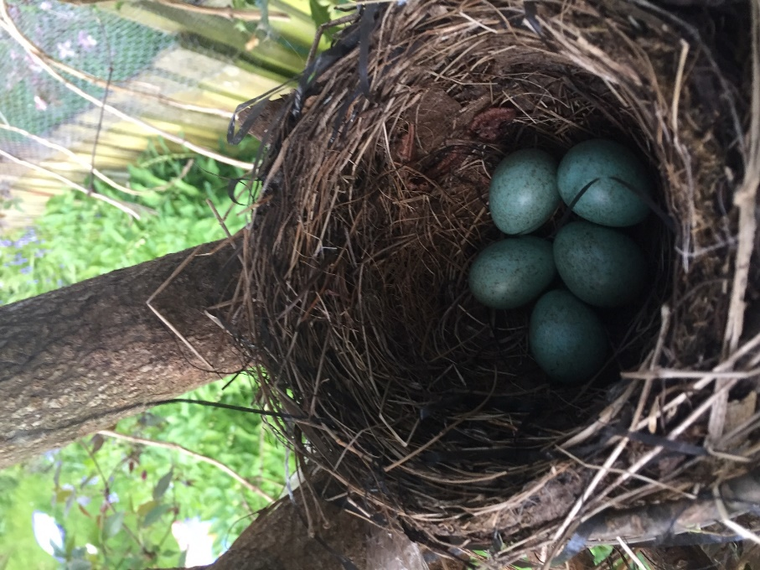

About a week after I found the nest 4 of the eggs hatched and they 4 baby blackbirds kept the last egg warm.
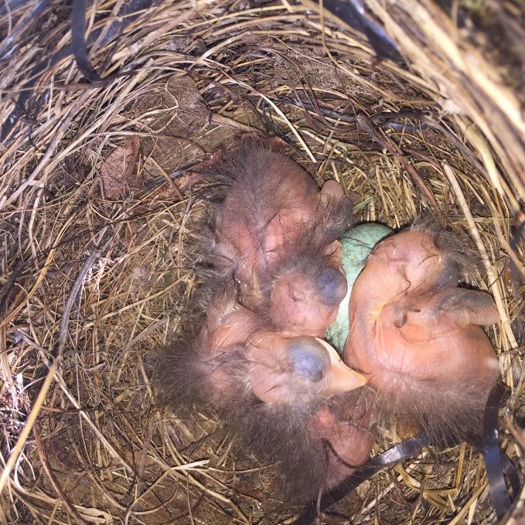

2 days later, the last egg hatched.
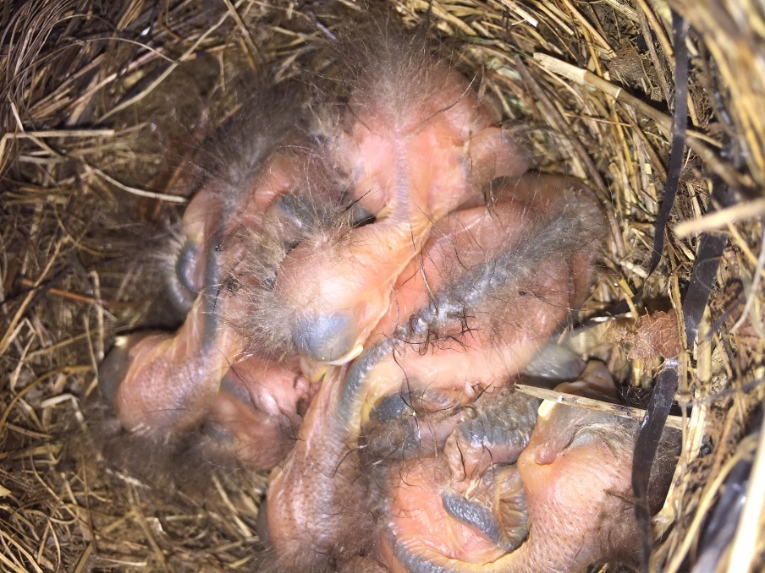

The baby blackbirds are pretty bald when they hatch but soon get black fluff that turns into feathers.

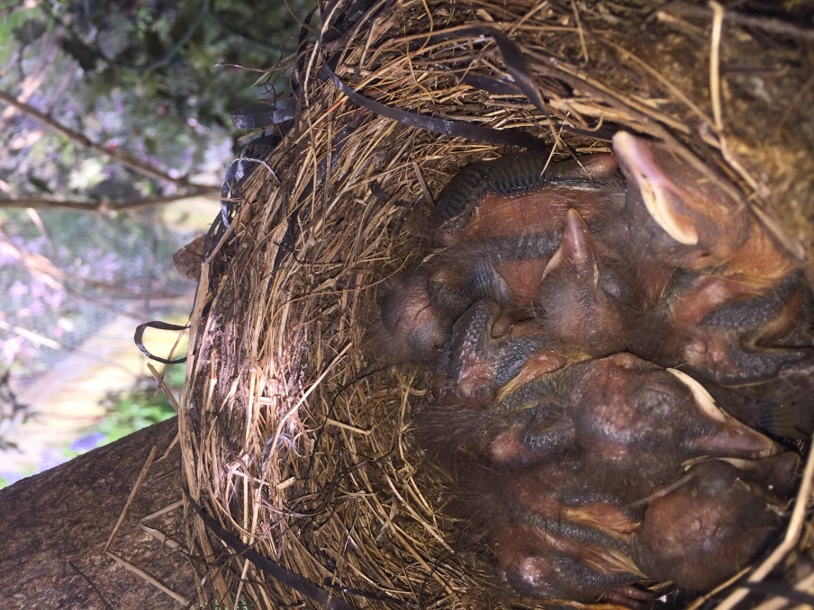

They grow really quickly and soon opened their eyes and started looking for food.

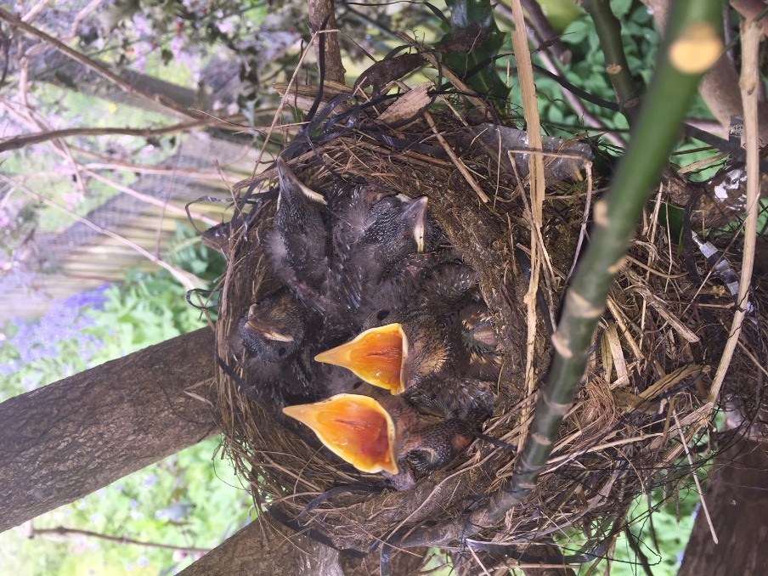

They filled the nest and were sitting on top on each other because they had no space and at 2 weeks old 4 of them flew away but one stayed all by itself.
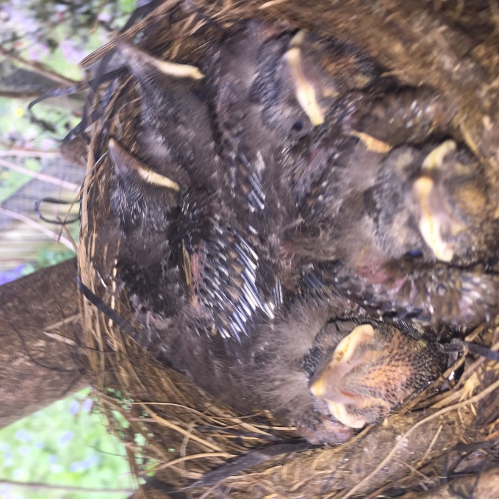
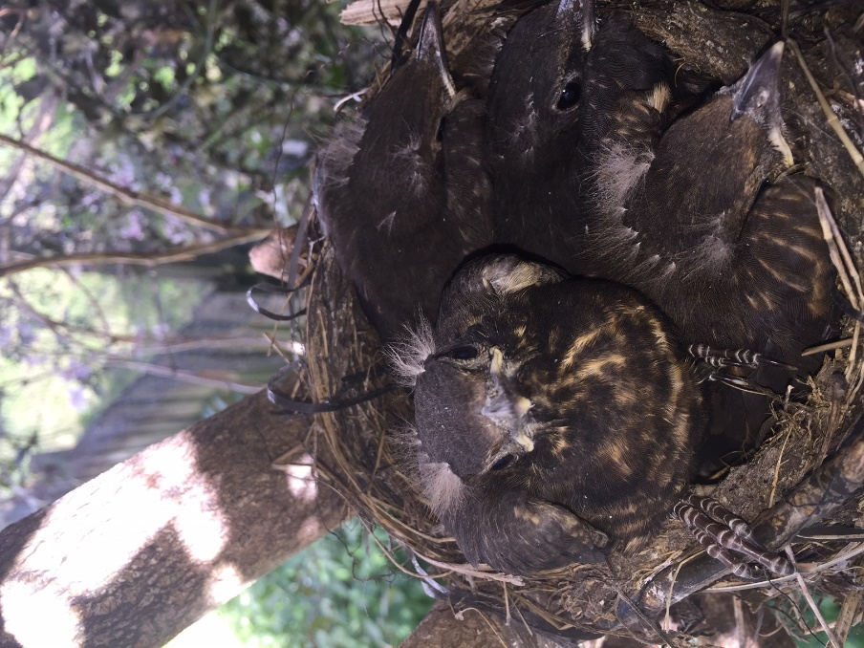

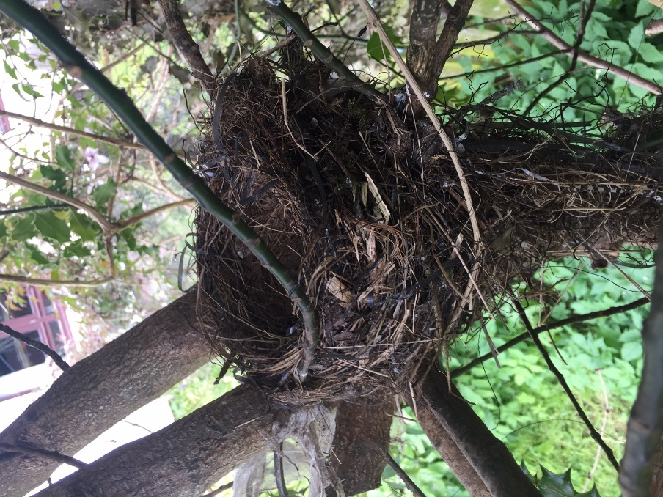

Part 2
I went out to check the nest the next morning and there was 2 new eggs. The next day there was 3 then 4 then 5. The nest was full again.
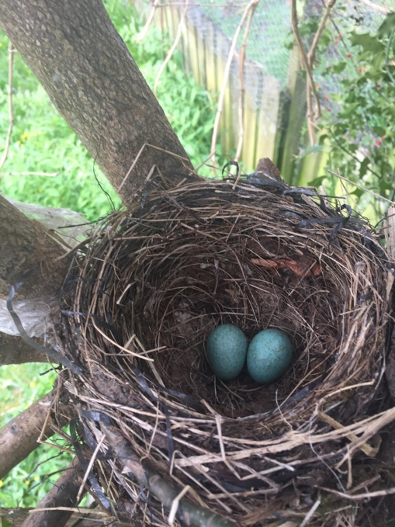
This time I decided to time how long it takes the needs to hatch. 14 days after I noticed the new eggs in the nest they all hatched.
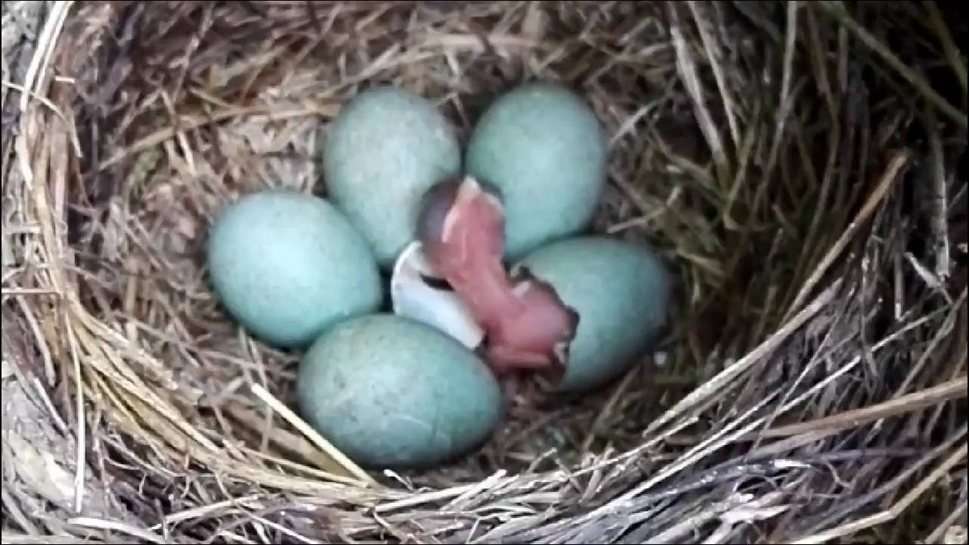
The blackbirds all grew up and left 13 days after hatching and then the same thing happened there was a new egg the very next day. This time we only got 4 eggs but I was lucky enough to get pictures of the birds hatching this time.

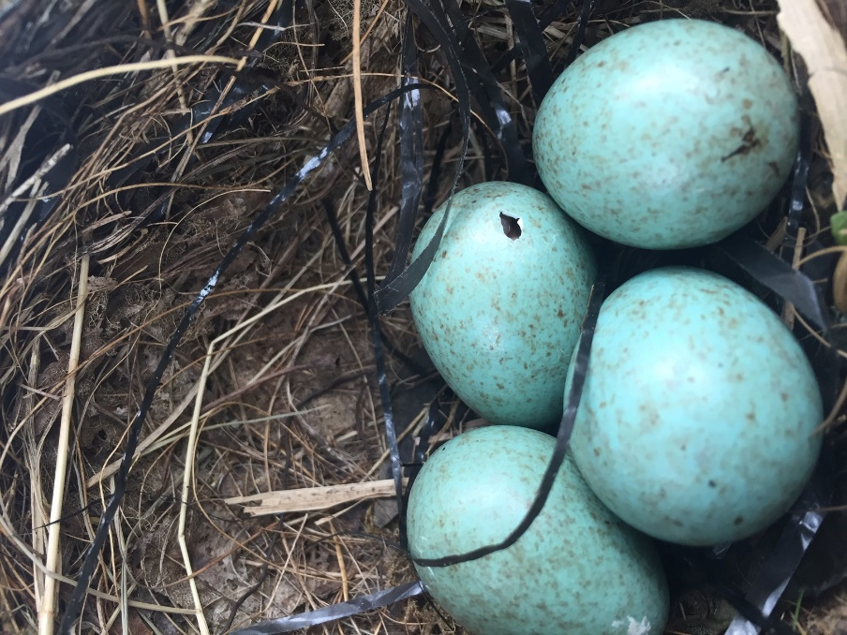
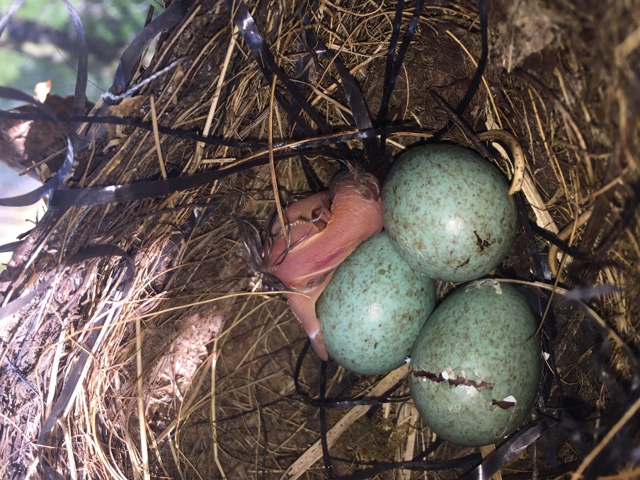
Again the baby birds kept the last egg warm and it hatched a day after the rest of them. It took over a day from me noticing the crack in the eggs to them actually hatching out of the shell.
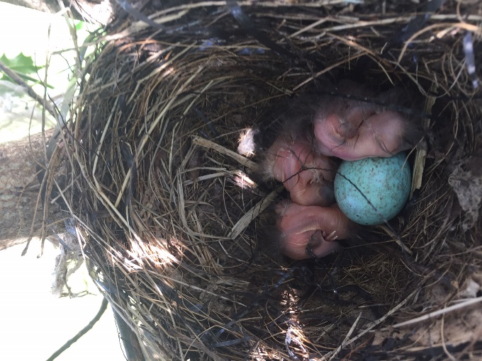
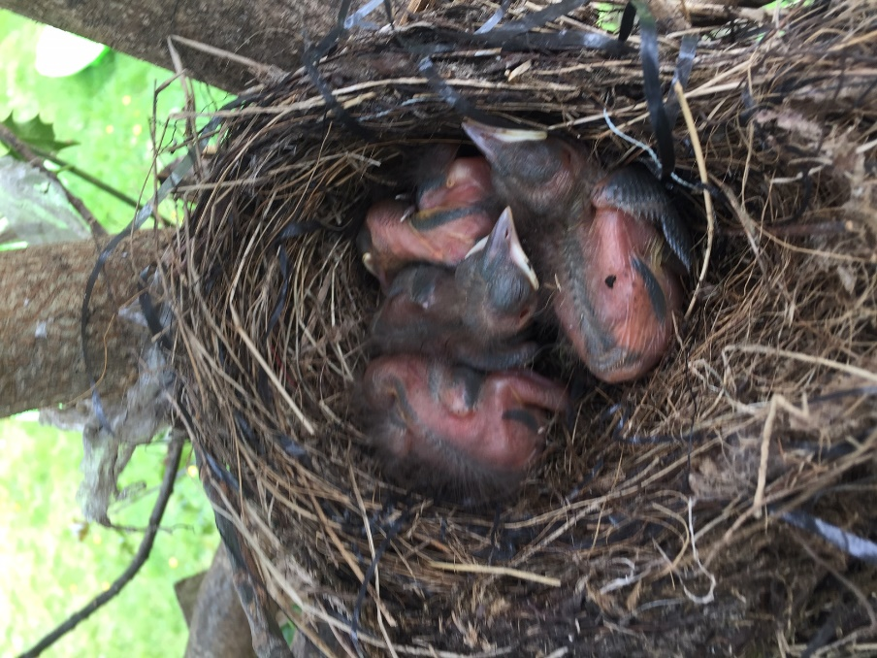
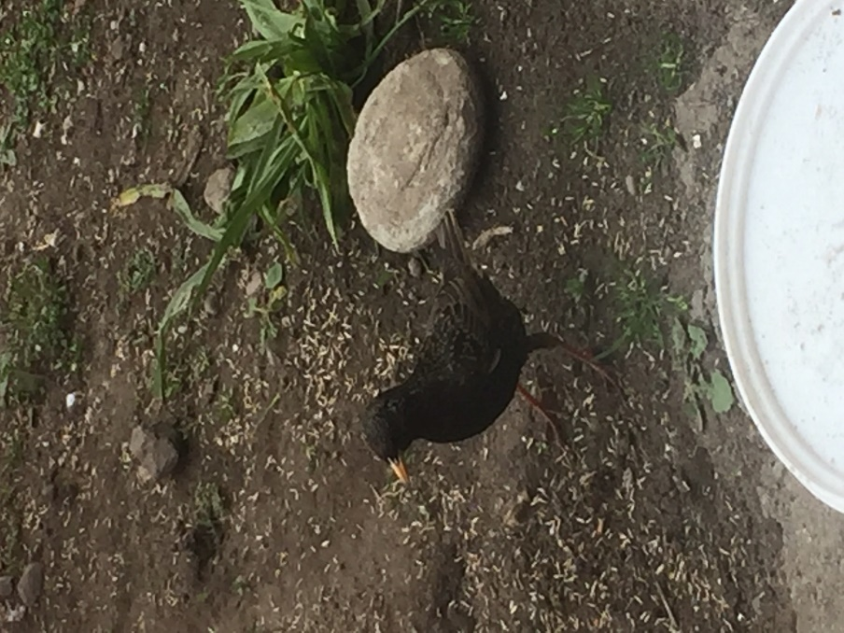
I like sitting and watching them and I like that the always come back to our garden. I have hundreds of pictures of them all now and my mum says when they have all left and she takes the nest down to cut the tree I can keep the nest.

